**PROTEUS SIMULATION**

**PROJECT:-**

AUTOMATIC STREET LIGHT

**CIRCUIT:-**

WHEN LED IS ON

(MEANS WHEN TORCH LIGHT IS NOT FALLING ON LDR )

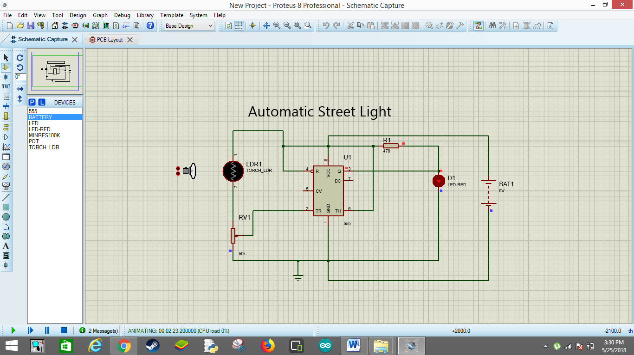

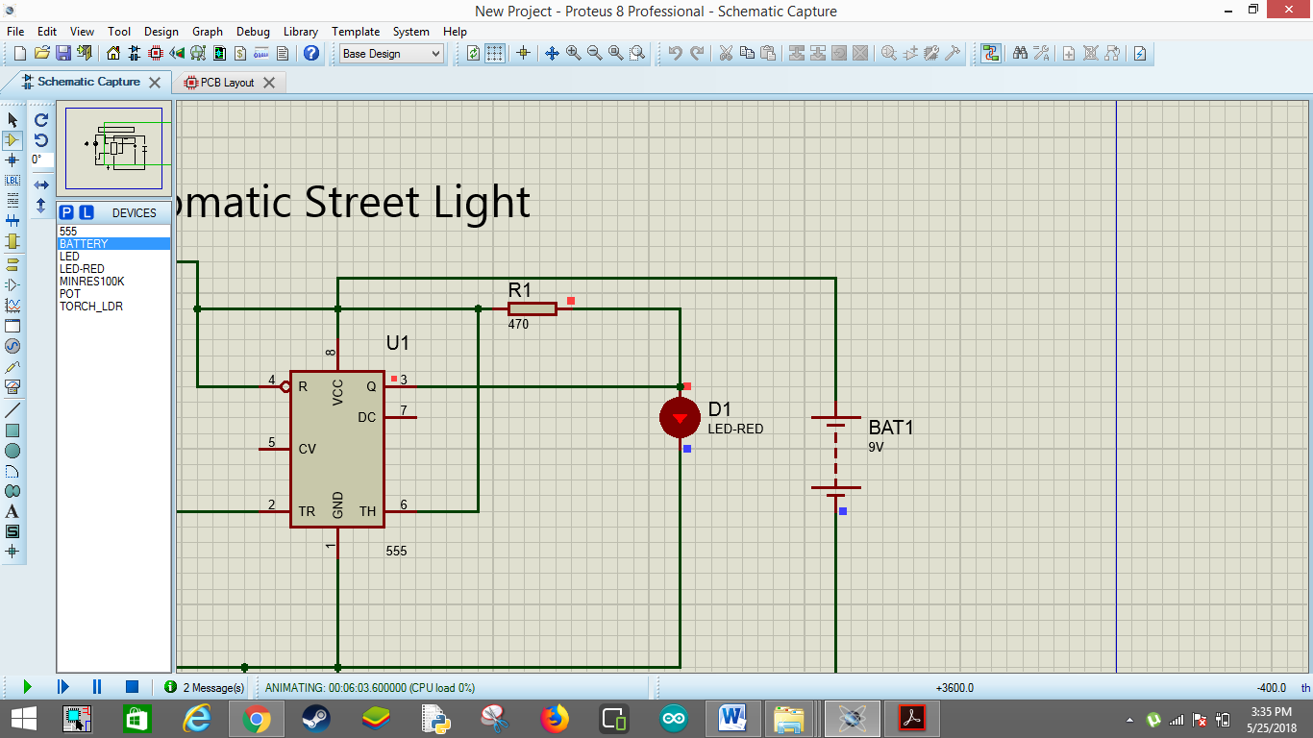

WHEN LED IS OFF

(MEANS WHEN TORCH LIGHT IS FALLING ON LDR )

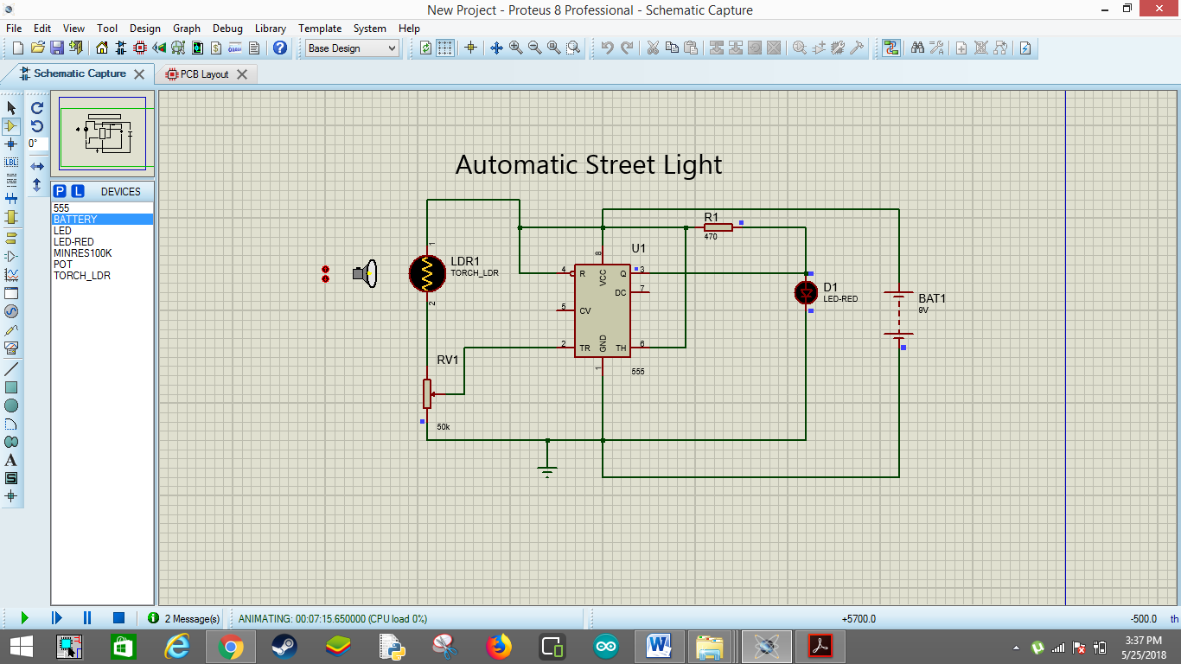

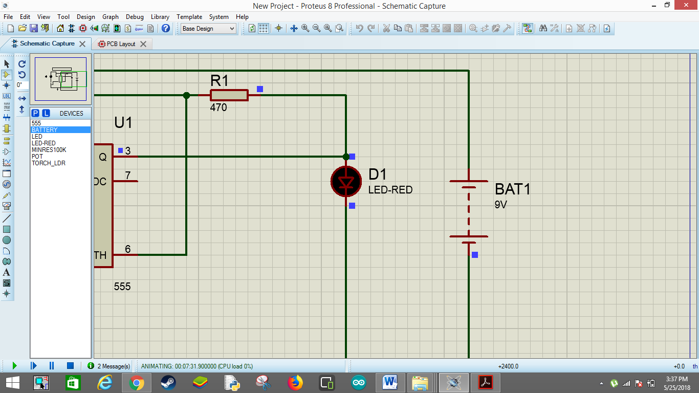

**Pull-up Resistors**

Pull-up resistors are simple fixed value resistors that are connected between the voltage supply and the particular pin. These resistors are used in digital logic circuits to ensure a logic level at a pin, which results in state wherein the input/output voltage is nonexistence driving signal. Digital logic circuits consist of three states like  high, low and floating or high impedance. When the pin is not pulled to a lower or a high logic level, then the high impedance state occurs. These resistors are used to solve the problem for the microcontroller by pulling the value to a high state, as seen in the figure. When the switch is open, the microcontrollers input would be floating and brought down only when the switch is closed. A typical pull-up resistor value is 4.7kilo Ohms, but can change depending on the application.

[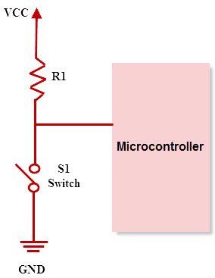](https://www.elprocus.com/wp-content/uploads/2014/11/Pull-up-resistor1.jpg)

Pull-up Resistor

**NAND Gate Circuit using Pull Up Resistor**

In this project, the pull-up resistor is wired up to a logic chip circuit. These circuits are the best circuits to test pull up resistors. Logic chip circuits work based on low or high signals. In this project, the NAND gate is taken as an example of logic chip. The main function of the NAND gate is, when both inputs of the NAND gate are low, then the output signal is high. In the same way, when the inputs of the NAND gate are high, then the output signal is low.

The required components for AND gate circuit using pull down resistors are NAND gate chip (4011), 10Kilo Ohm resistors-2, Pushbuttons-2, 330ohm resistor and LED.

* Each NAND gate consists of two I/P and one O/P pin.
* Two push buttons are used as an inputs to the AND gate.
* The pull-up resistor value is 10 kilo Ohm and the remaining components are 330 Ohm resistor and LED. The 330 Ohm resistor is connected in series to limit the current to the LED

The circuit diagram of the NAND gate using 2-pull down resistors at the i/ps to the NAND gate is shown below.

[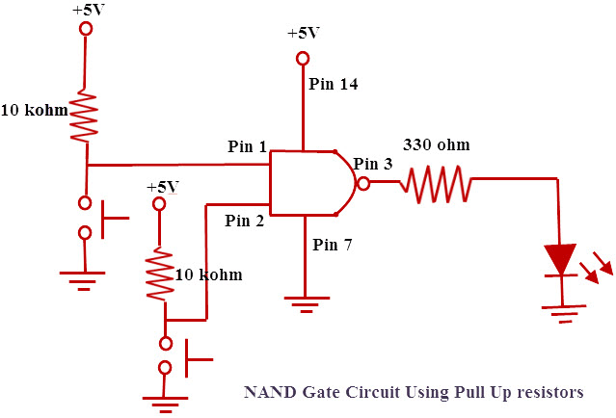](https://www.elprocus.com/wp-content/uploads/2014/11/NAaaaaaAND-Gate-Circuit-Using-Pull-Up-resistors.jpg)

NAND Gate Circuit using Pull -up Resistor

In this circuit, to give power to the chip it is fed with 5V. So, +5V is given to the pin 14 and the pin7 is connected to the ground. Pull-up resistors are connected to the NAND gate inputs. A pull up resistor is connected to the first input of the NAND gate and positive voltage. A push button is connected to GND. When the push button is not pressed, the NAND gate input is high. When a push button is pressed, the NAND gate input is low. For the NAND gate, both I/Ps must be low to get an output high. In order to work the owl circuit, you must press down on both buttons. This shows the great usefulness of pull-up resistors.

### Pull-Down Resistors

As pull up resistors, Pull-down resistors also works in the same way. But, they pull the pin to a low value. Pull-down resistors are connected between a particular pin on a microcontroller and the ground terminal. An example of a pull down resistor is a digital circuit shown in the figure below. A switch is connected between the VCC and the microcontroller pin. When the switch is closed in the circuit, the input of the microcontroller is logic 1,but when the switch is open in a circuit, the pull down resistor pulls down the input voltage to the ground (logic 0 or logic low value). The pull down resistor should have a higher resistance than the impedance of the logic circuit.

[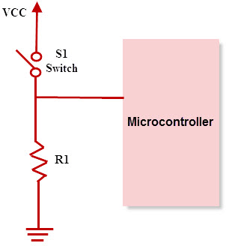](https://www.elprocus.com/wp-content/uploads/2014/11/Pull-down-Resistor.jpg)

**And Gate Circuit using Pull Down Resistor**

In this project, the pull-down resistor is wired up to a logic chip circuit. These circuits are the best circuits to test pull-down resistors. The Logic chip circuits work based on the low or high signals. In this project, AND gate is taken as an example of the logic chip.The main function of the AND gate is, when both inputs of the AND gate are high, then the output signal is high. In the same way when the inputs of the AND gate are low, then the output signal is low.

The required components for AND gate circuit using a pull-down resistors are AND gate chip(SN7408), 10Kilo Ohm resistors-2, Push buttons-2, 330 Ohm resistor and LED.

* Each AND gate consists of two I/P and one O/P
* Two push buttons are used as an inputs to the AND gate.
* The pull-down resistor value is 10 kilo Ohm and the remaining components are 330 Ohm resistor and LED. The 330 Ohm resistor is connected in series to limit the current to the LED.

The circuit diagram of the AND gate using 2-pull down resistors at the i/ps to the AND gate is shown below.

[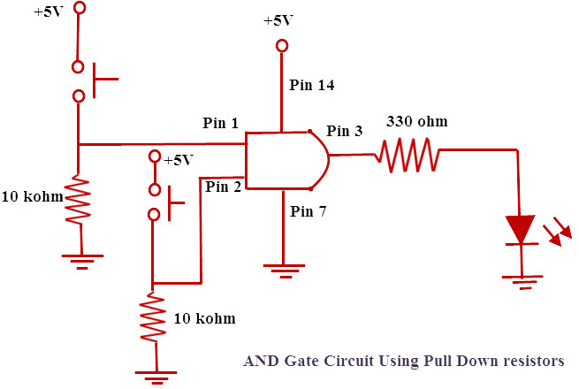](https://www.elprocus.com/wp-content/uploads/2014/11/123.jpg)

And Gate Circuit using Pull Down Resistor

In this circuit, to give power to the chip, it is fed with 5V. So, +5V is given to pin 14 and pin7 is connected to the ground. The Pull-down resistors are connected to the AND gate inputs. One pull down resistor is connected to the first input of the AND gate.The pushbutton is connected to the positive voltage, and then, a pull-down resistor is connected to GND. If the push button is not pressed, AND gate input will be low. If the push button is pressed, AND gate input will be high.For AND gate, both I/Ps must be high to get an output high. In order to work the owl circuit, you must press down both the buttons.This shows the great usefulness of pull-down resistors.

**Applications of Pull-Up and Pull-Down Resistors**

* Pull-up and pull-down resistors are frequently used in interfacing devices like interfacing a switch to microcontroller.
* Most if the microcintrollers have inbuilt programmable pull up/pull down resistors.So Interfacing a switch with a microcontroller directly is possible.
* In general, pull up resistors are often used than pull down resistors, although some microcontroller families have both pull-up and pull-down resistors.
* These resistors are often used in A/D converters to provide a controlled flow of current into a resistive sensor
* Pull-up and pull-down resistors are used in I2C protocol bus, wherein the pull-up resistors are used to allow a single pin to act as an I/P or O/P.
* When it is not connected to a I2C protocol bus, the pin floats in a high impedance state. Pull down resistors are also used for outputs to afford a known O/P.

**MOSFET AS A SWITCH**

**MOSFETs** exhibit three regions of operation viz., Cut-off, Linear or Ohmic and Saturation.

#Among these, when MOSFETs are to be used as amplifiers, they are required to be operated in their ohmic region wherein the current through the device increases with an increase in the applied [voltage](https://www.electrical4u.com/voltage-or-electric-potential-difference/).

#On the other hand, when the [MOSFETs](https://www.electrical4u.com/mosfet-working-principle-of-p-channel-n-channel-mosfet/) are required to function as switches, they should be biased in such a way that they alter between cut-off and saturation states. This is because, in cut-off region, there is no [current](https://www.electrical4u.com/electric-current-and-theory-of-electricity/) flow through the device while in saturation region there will be a constant amount of current flowing through the device, just mimicking the behaviour of an open and closed switch, respectively.

#This functionality of MOSFETs is exploited in many electronic circuits as they offer higher switching rates when compared to BJTs ([bipolar junction transistors](https://www.electrical4u.com/bipolar-junction-transistor-or-bjt-n-p-n-or-p-n-p-transistor/)).

Figure 1 shows a simple circuit which uses an n-channel enhancement **MOSFET as a switch**. Here the drain terminal (D) of the **MOSFET** is connected to the supply voltage VS via the drain [resistor](https://www.electrical4u.com/types-of-resistor-carbon-composition-and-wire-wound-resistor/) RD while its source terminal (S) is grounded. Further, it has an input voltage Vi applied at its gate terminal (G) while the output Vo is drawn from its drain.

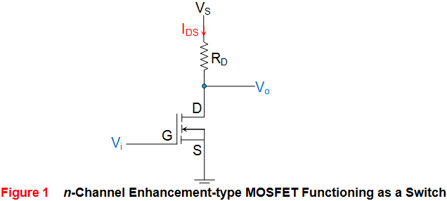

Now consider the case where Vi applied is 0V, which means the gate terminal of the MOSFET is left unbiased. As a result, the MOSFET will be OFF and operates in its cutoff region wherein it offers a high impedance path to the flow of current which makes the IDS almost equivalent to zero. As a result, even the voltage drop across RD will become zero due to which the output voltage Vo will become almost equal to VS. Next, consider the case where the input voltage Vi applied is greater than the threshold voltage VT of the device. Under this condition, the MOSFET will start to conduct and if the VS provided is greater than the pinch-off voltage VP of the device (usually it will be so), then the MOSFET starts to operate in its saturation region. This further means that the device will offer low [resistance](https://www.electrical4u.com/electrical-resistance-and-laws-of-resistance/) path for the flow of constant IDS, almost acting like a short circuit. As a result, the output voltage will be pulled towards low voltage level, which will be ideally zero.

From the discussion presented, it is evident that the output voltage alters between VS and zero depending on whether the input provided is less than or greater than VT, respectively. Thus, it can be concluded that MOSFETs can be made to function as electronic switches when made to operate between cut-off and saturation operating regions. Similar to the case of n-channel enhancement type MOSFET, even n-channel depletion type MOSFETs can be used to perform switching action as shown by Figure 2. The behaviour of such a circuit is seen to be almost identical to that explained above except the fact that for cut-off, the gate voltage VG needs to be made negative and should be lesser than -VT.

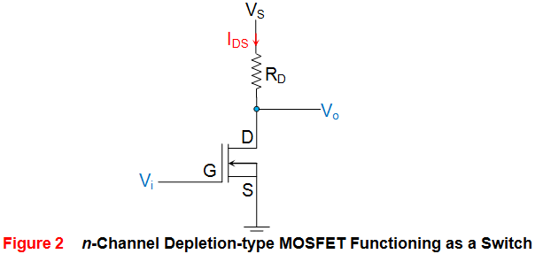Next, Figure 3 shows the case wherein the p-channel enhancement MOSFET is used as a switch. Here it is seen that the supply voltage VS is applied at its source terminal (S) and the gate terminal is provided with the input voltage Vi while the drain terminal is grounded via the resistor RD. Further the output of the circuit Vo is obtained across RD, from the drain terminal of the MOSFET. In the case of p-type devices the conduction current will be due to holes and will thus flow from source to drain ISD, and not from drain to source (IDS) as in the case of n-type devices. Now, let us assume that the input voltage which is nothing but the gate voltage VG of the MOSFET goes low. This causes the MOSFET to switch ON and to offer a low (almost negligible) resistance path to the current flow. As a result heavy current flows through the device which results in a large voltage drop across the resistor RD. This inturn results in the output which is almost equal to the supply voltage VS. 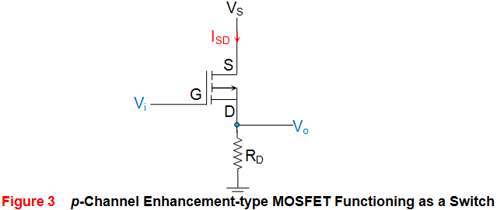Next, consider the case where Vi goes high i.e. when Vi will be greater than the threshold voltage of the device (VT will be negative for these devices). Under this condition, the **MOSFET** will be OFF and offers a high impedance path for the current flow. This results in almost zero current leading to almost zero voltage at the output terminal.

Similar to this, even p-channel depletion-type **MOSFETs** can be used to perform switching action as shown by Figure 4. The working of this circuit is almost similar to the one explained above except for the fact that here the cut-off region is experienced only if Vi = VG is made positive such that it exceeds the threshold voltage of the device. 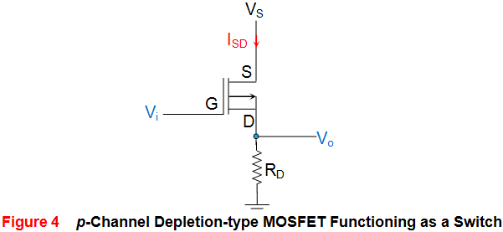The table presented below summarizes the discussion presented above. 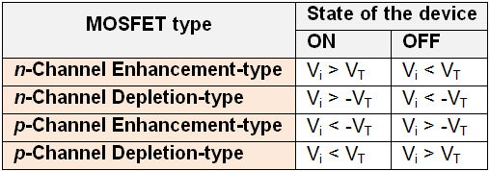

PNEUMATIC SOLENOID VALVE

Pneumatic Actuated

Pneumatic actuation refers to a valve being tripped through the use of compressed air (gas). At a particular point in an industrial or manufacturing process, compressed air is released, causing a valve to open or close. The combination of solenoids and pneumatics is twofold. Solenoid valves are used in pneumatic processes and solenoid valves and pneumatic valves are used in combination. The combined valve is called a piloted valve. The larger solenoid valve is triggered by the smaller pneumatic valve. The pneumatic valve can act as an air cylinder contained in a main valve. A pneumatic solenoid valve is also referred to as a compressed air pilot valve.

## Types of Pneumatic Solenoid Valves

Valves can be designated as internally piloted or externally piloted. The valves can further be categorized by the number of connections or paths for flow they contain. Externally piloted valves use an external source of air pressure. Internally piloted use an internal source of air pressure. Two-way piloted valves can be used in dust collector systems. An internally driven pilot valve with four-way connections are generally found in pneumatic operations and are used to move double action cylinders. Pneumatic solenoid valves can be designed as stackable.

### How is a solenoid operated valve being made?

## THERE ARE 5 MAIN PARAMETERS TO CONSIDER WHEN SELECTING A VALVE:

* Cv
* media compatibility
* pressure
* temperature
* process fitting

Solenoid valve is a control units which, when electrically energized or de-energized, either shut off or allow fluid flow. The actuator takes the form of an electromagnet. When energized, a magnetic field builds up which pulls a plunger or pivoted armature against the action of a spring. When de-energized, the plunger or pivoted armature is returned to its original position by the spring action. 

### How does a solenoid valve operate?

To the mode of actuation, a distinction is made between direct- valves, internally piloted valves, and externally piloted valves. A further distinguishing feature is the number of port connections or the number of flow paths ("ways"). 

### Direct-acting solenoid valve

With a direct-acting solenoid valve, the seat seal is attached to the solenoid core. In the de-energized condition, a seat orifice is closed, which opens when the valve is energized. 

### Direct-acting 2-way solenoid valve

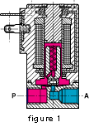Two-way solenoid operated valves are shut-off valves with one inlet port and one outlet port (Fig. 1). In the de-energized condition, the core spring, assisted by the fluid pressure, holds the valve seal on the valve seat to shut off the flow. When energized, the core and seal are pulled into the solenoid coil and the valve opens. The electro-magnetic force is greater than the combined spring force and the static and dynamic pressure forces of the medium.

### Direct-acting 3-way solenoid valve operation

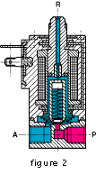Three-way solenoid operated valves have three port connections and two valve seats. One valve seal always remains open and the other closed in the de-energized mode. When the coil is energized, the mode reverses. The 3-way solenoid valve shown in Fig. 2 is designed with a plunger type core. Various valve operations can be obtained according to how the fluid medium is connected to the working ports in Fig. 2. The fluid pressure builds up under the valve seat. With the solenoid coil de-energized, a conical spring holds the lower core seal tightly against the valve seat and shuts off the fluid flow. Port A is exhausted through R. When the coil is energized the core is pulled in, the valve seat at Port R is sealed off by the spring-loaded upper core seal. The fluid medium now flows from P to A. 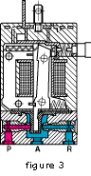Unlike the versions with plunger-type cores, pivoted-armature valves have all port connections in the valve body. An isolating diaphragm ensures that the fluid medium does not come into contact with the solenoid coil chamber. Pivoted-armature valves can be used to obtain any 3-way valve operation. The basic design principle is shown in Fig. 3. Pivoted-armature valves are provided with manual override as a standard feature. 

### Internally piloted solenoid valve

With direct-acting valves, the static pressure forces increase with increasing orifice diameter which means that the magnetic forces, required to overcome the pressure forces, become correspondingly larger. Internally piloted solenoid valves are therefore employed for switching higher pressures in conjunction with larger orifice sizes; in this case, the differential fluid pressure performs the main work in opening and closing the valve. 

### Internally piloted 2-way solenoid valve

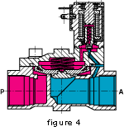Internally piloted solenoid valves are fitted with either a 2- or 3-way solenoid valve. A diaphragm or a piston provides the seal for the main valve seat. The operation of such a valve is indicated in Fig. 4. When the pilot valve is closed, the fluid pressure builds up on both sides of the diaphragm via a bleed orifice. As long as there is a pressure differential between the inlet and outlet ports, a shut-off force is available by virtue of the larger effective area on the top of the diaphragm. When the pilot valve is opened, the pressure is relieved from the upper side of the diaphragm. The greater effective net pressure force from below now raises the diaphragm and opens the valve. In general, internally piloted valves require a minimum pressure differential to ensure satisfactory opening and closing. Omega also offers internally piloted valves, designed with a coupled core and diaphragm that operate at zero pressure differential (Fig. 5). 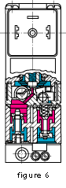

### Internally piloted multi-way solenoid valve

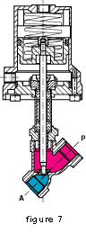Internally piloted 4-way solenoid valves are used mainly in hydraulic and pneumatic applications to actuate double-acting cylinders. These valves have four port connections: a pressure inlet P, two cylinder port connections A and B, and one exhaust port connection R. An internally piloted 4/2-way poppet valve is shown in Fig. 6. When de-energized, the pilot valve opens at the connection from the pressure inlet to the pilot channel. Both poppets in the main valve are now pressurized and switch over. Now port connection P is connected to A, and B can exhaust via a second restrictor through R. 

### Externally piloted solenoid valve

With these types an independent pilot medium is used to actuate the valve. Fig. 7 shows a piston-operated angle-seat valve with closure spring. In the unpressurized condition, the valve seat is closed. A 3-way solenoid valve, which can be mounted on the actuator, controls the independent pilot medium. When the solenoid operated valve is energized, the piston is raised against the action of the spring and the valve opens. A normally-open valve version can be obtained if the spring is placed on the opposite side of the actuator piston. In these cases, the independent pilot medium is connected to the top of the actuator. Double-acting versions controlled by 4/2-way valves do not contain any spring. 

**Must Watch:**

https://www.youtube.com/watch?v=Vb0yov7UFy8

GO through these tutorials for arduino interfacing with the solenoid valve:

https://www.bc-robotics.com/tutorials/controlling-a-solenoid-valve-with-arduino/